Building A Dashboard With IBM Cognos Analytics

Current Technology Usage
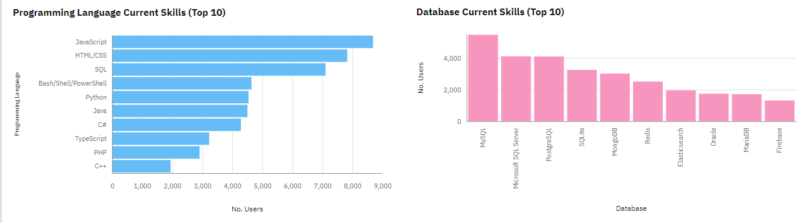
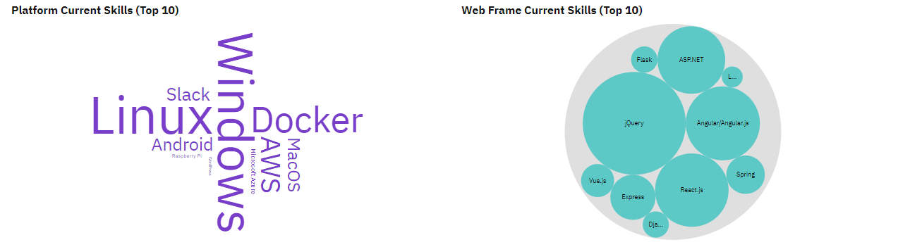

Future Technology Usage

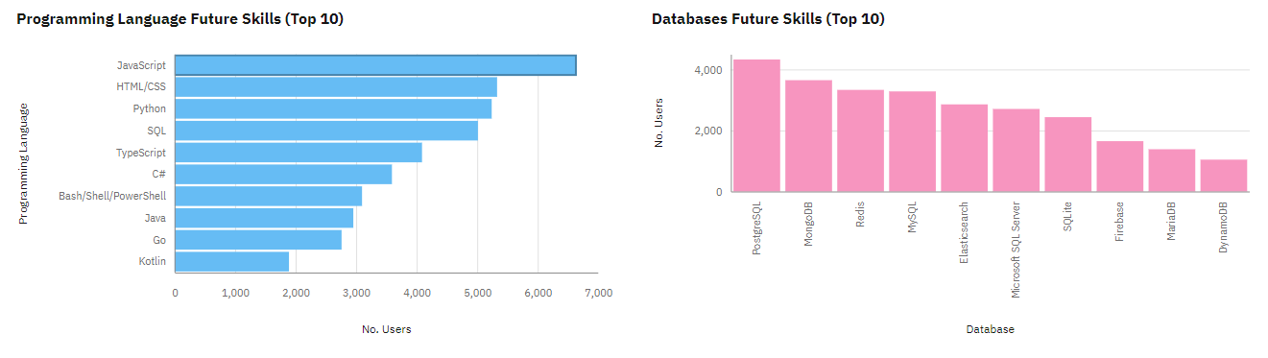
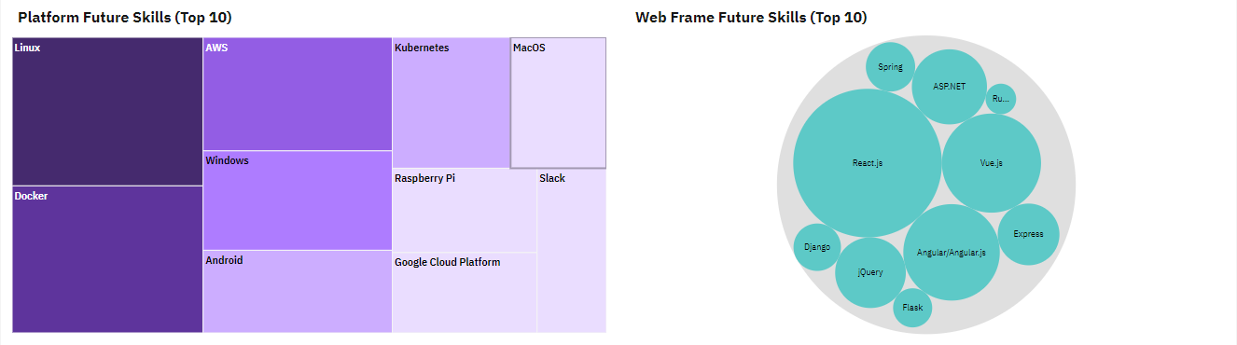

Demographics
